|  |  |
| --- | --- |
| NAME: _____________ | **Statistics** |
| Sampling – Means | **DATE: Monday, April 24, 2017** |

What is your sample size? _______

|  |  |  |  |  |  |  |  |  |  |
| --- | --- | --- | --- | --- | --- | --- | --- | --- | --- |
|  |  |  |  |  |  |  |  |  |  |
|  |  |  |  |  |  |  |  |  |  |
|  |  |  |  |  |  |  |  |  |  |
|  |  |  |  |  |  |  |  |  |  |
|  |  |  |  |  |  |  |  |  |  |
|  |  |  |  |  |  |  |  |  |  |

Find mean: standard deviation:

|  |  |  |  |
| --- | --- | --- | --- |
| Classes | Tally | Frequency | Percent |
|  |  |  |  |
|  |  |  |  |
|  |  |  |  |
|  |  |  |  |
|  |  |  |  |
|  |  |  |  |
|  |  |  |  |
|  |  |  |  |
|  |  |  |  |
|  |  |  |  |

Create a frequency distribution

- use at least 8 classes.

What percent are within

2 standard deviation?

For means, the standard deviation of a sample size n is:

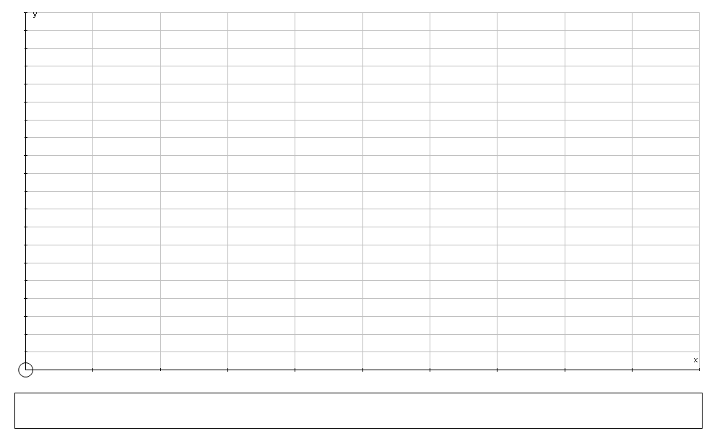

Where:

* **S.D.** is the sample standard deviation
* **n** is the sample size. This is the size of your sample.

Standard Deviation of Means

|  |
| --- |
| For large populations |
|  |

To be 95% confident is about 2 standard deviations (1.96 to be exact). **So we will use 2 for a Z-score.**

Find the confidence interval:

|  |  |
| --- | --- |
| We conduct a survey of 30 random students. The average height for a graduating senior boy at Deering is 68.5 inches and the standard deviation of the group is: 4.2 inches. Create a 95% confidence interval for the true mean height. | We ask 50 random adults how much money they make per week. The average salary was $ 785 and the standard deviation of the group is $340. Create a 95% confidence interval for the true mean pay per week. |
| We find that the average SAT score of 240 random students is 985 and the sample standard deviation is 110 points. Create a 95% confidence interval for the true mean score. | In science class, we find the amount of acid at 25 spots around the lake. The average was 6.2 and it the sample deviated by 1.3. Create a 95% confidence interval for the true average acidic level. |
| Advanced:  We find that the average SAT score of 240 random students is 985 and the sample standard deviation is 110 points. Create a 90% confidence interval for the true mean score. | Advanced:  We find that the average SAT score of 240 random students is 985 and the sample standard deviation is 110 points. Create a 99% confidence interval for the true mean score. |